* **How to connect windows AD server to aws**

1. **To launch an instance & connect to the server with the help of RDP.**
2. Windows server 2012 R2 base .

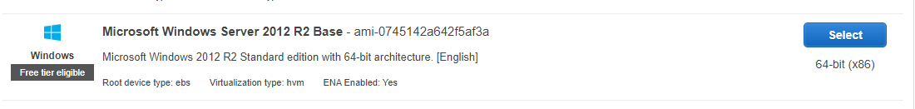

1. Instance type t2 micro, it is eligible for free tire account.



1. I select one instance and everything is default like vpc, subnet , availability zone 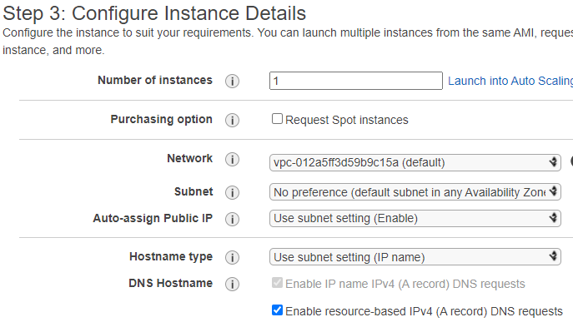

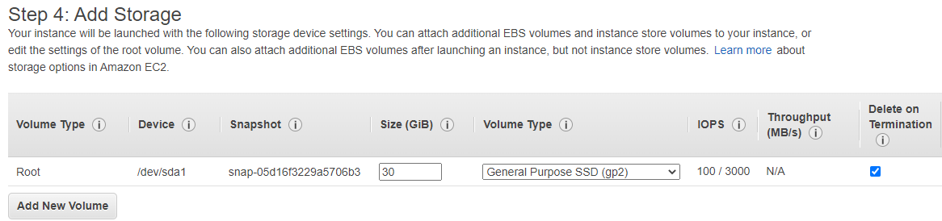

1. Tag is “AD-server”

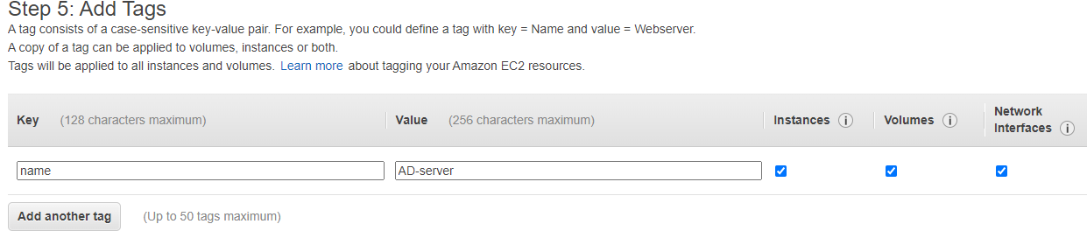

1. Security group is “newsg”

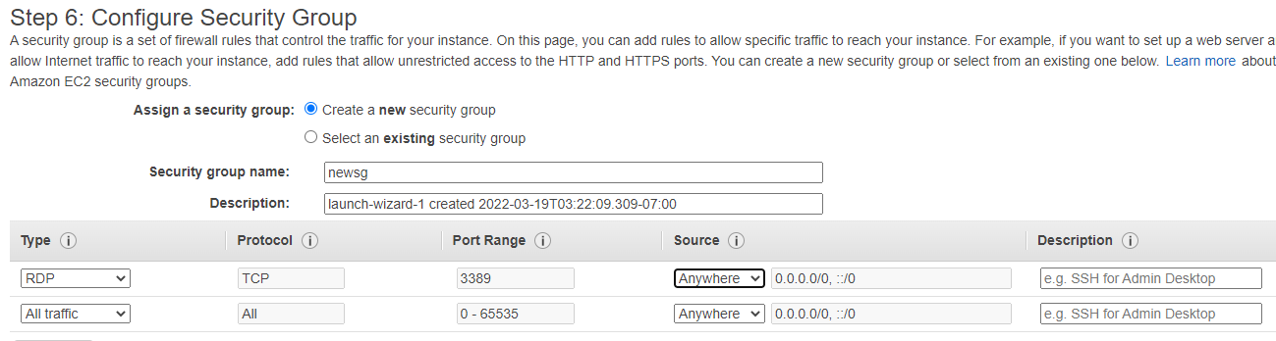

1. I create new keypair as ad-server-keypair.

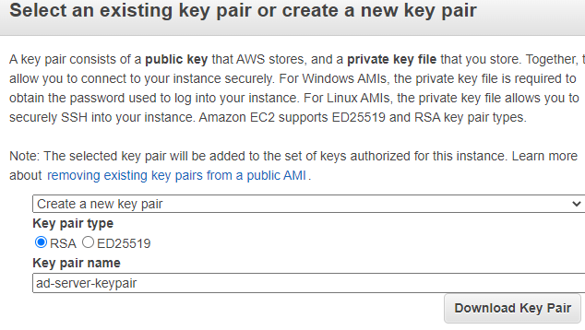

1. I connected to the windows server 2012 R2 base, it private ip is 172.31.88.163

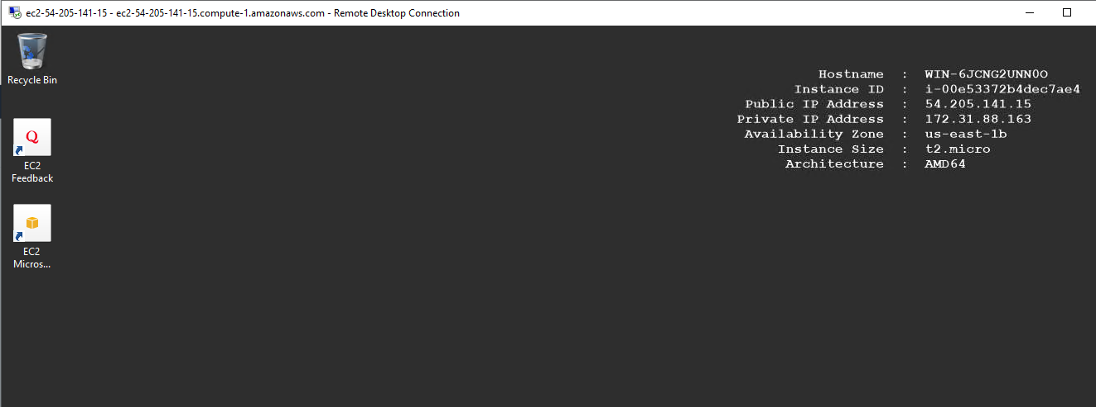

Windows **>** control panel **>** account **>** changed password

Here is changed the password of this windows sever as “gautam@123”.

**1.1 install AD server on windows server 2012 R2 base**

1. Go to server manager dashboard > add role & features 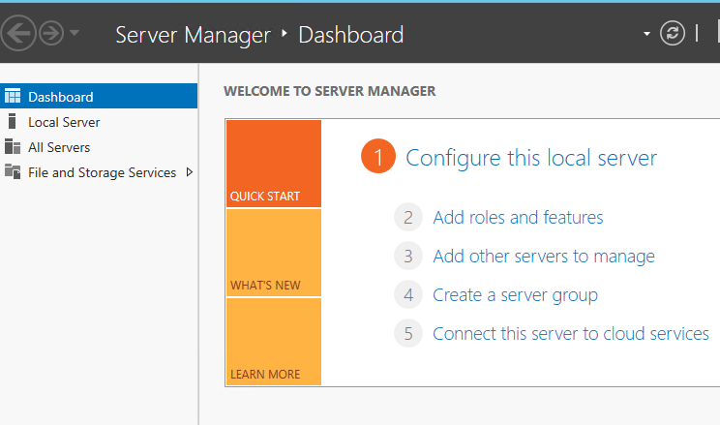
2. 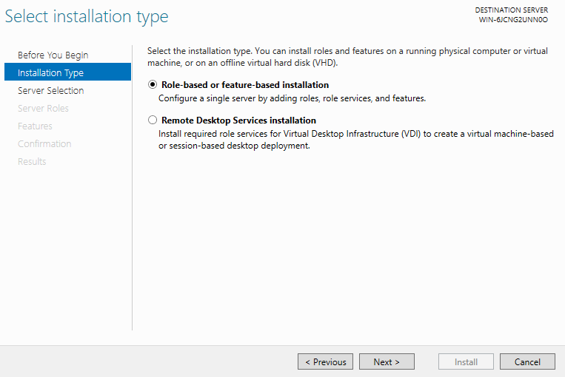
3. 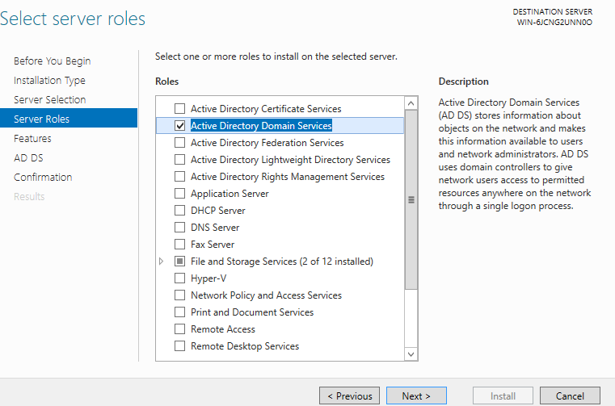
4. Ad server is successfully installed and i back on my home page of server.

**1.2 Now create one forest “rishigyanu.in”**

1. Go to server manager notification and click on that.



1. Click on ”promote this server to s domain controller”

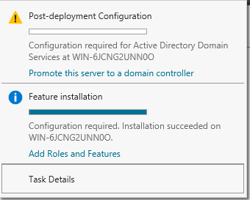

1. Add a new forest and root domain name “rishigyanu.in”

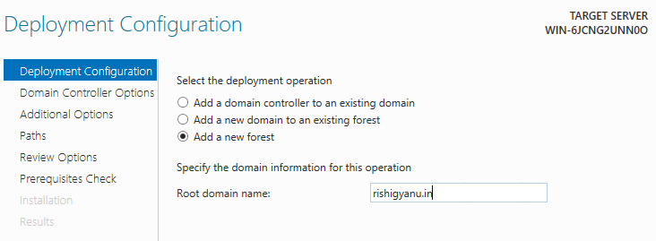

1. Set the password as “truth@123” and conform.

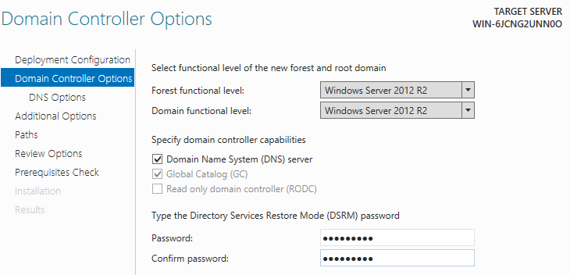

1. Click on next.

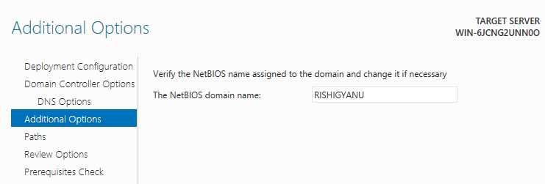

1. Click on next.

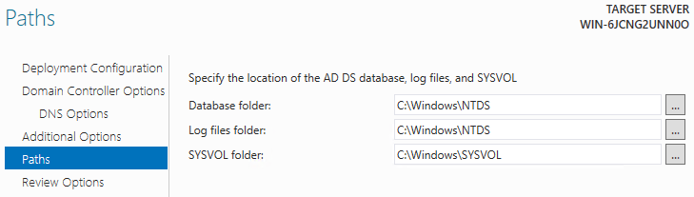

1. Click on next.

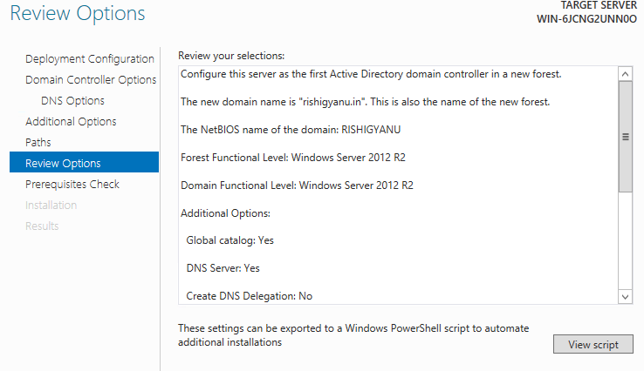

1. Here show all prerequisite check passed successfully. Click stall to begin installation.

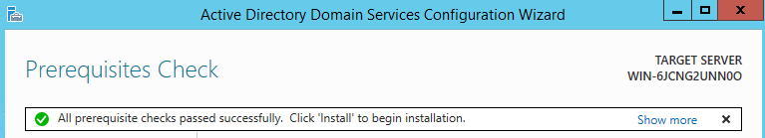

1. Their installation is started.

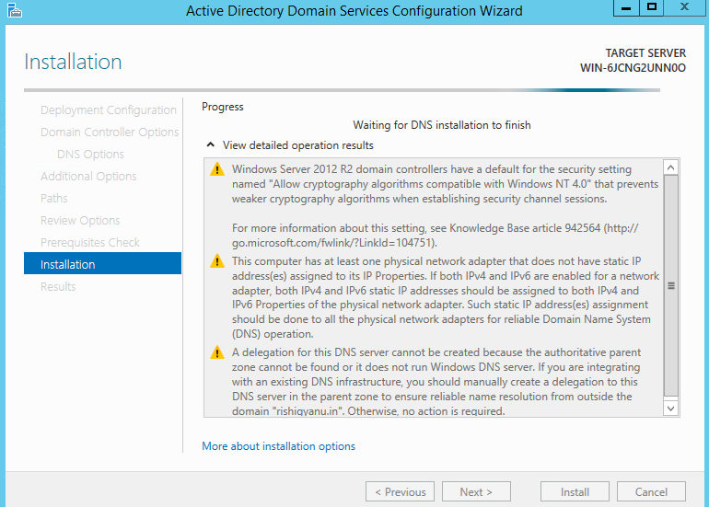

1. After installed it reboot and connect again to the server with the help of rdp and put password which changed “gautam@123”

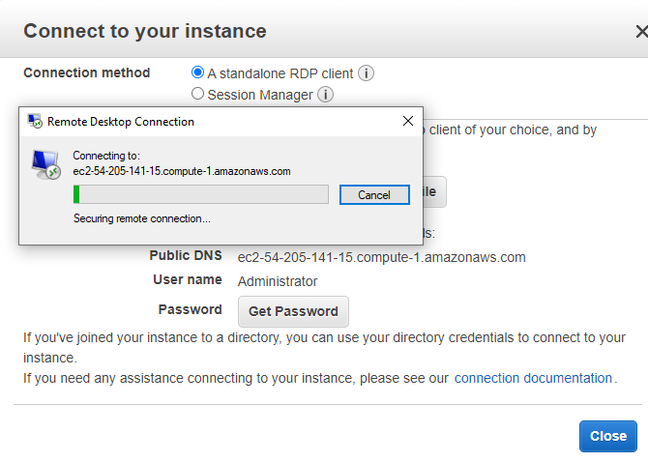

**1.3 Now go to server manager > tools > DNS > reverse lookup and forward lookup.**



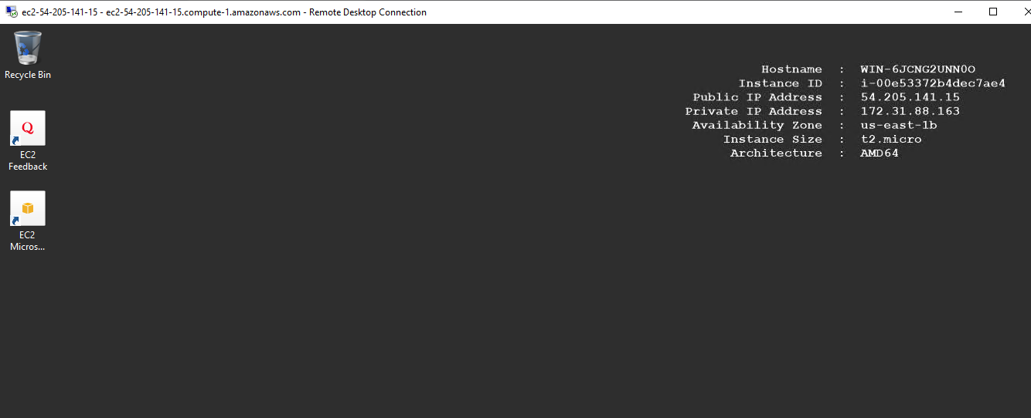



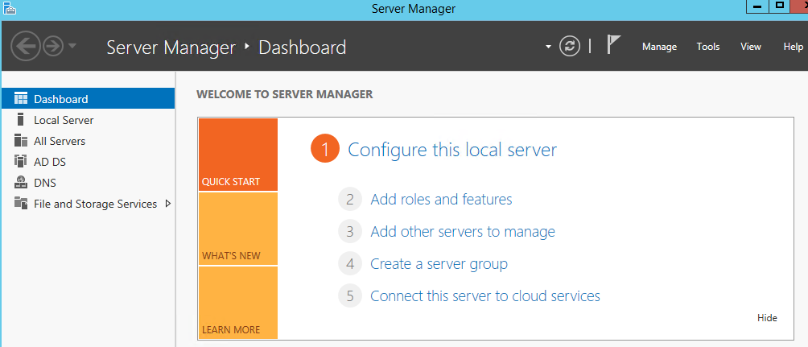



1. Select tools and click on DNS.

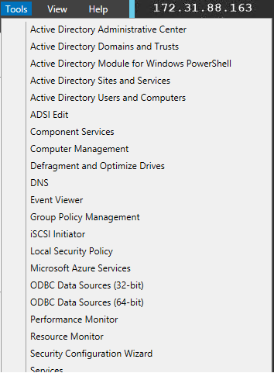

1. DNS **>** reverse lookup zone **>** click on mouse of right side **>** new zone .

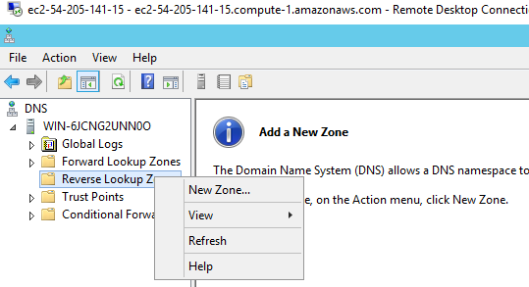

1. Click on next

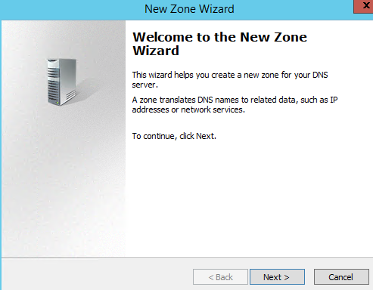

1. Select Primary zone and click on next.

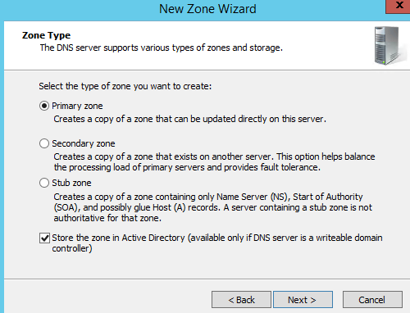

1. Click on next.

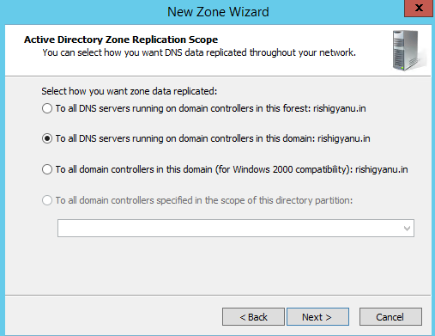

1. Select ipv4 and click on next.

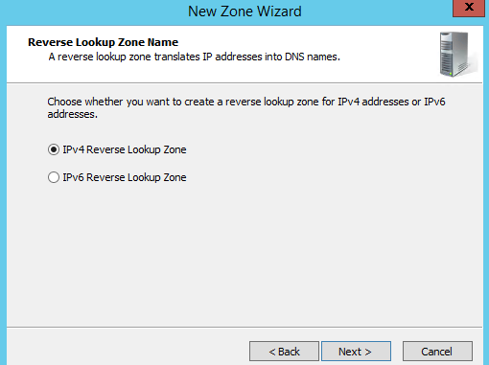

1. Fill the network id of windows server 2012 R2 base ip address 172.31.88.

I can fill only three octet and click on next.

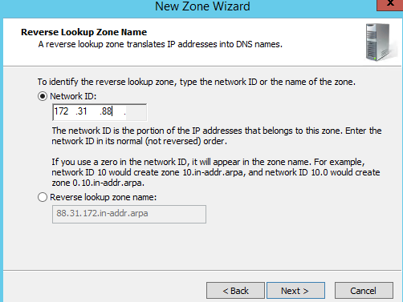

1. Click on finish

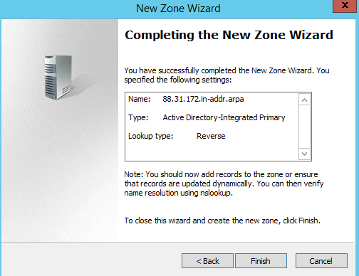

1. Now select the “forward lookup zone”

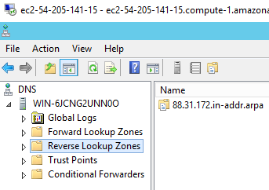

1. Forward lookup zone > domain as rishigyanu.in > server “win-6jcng2un0o”

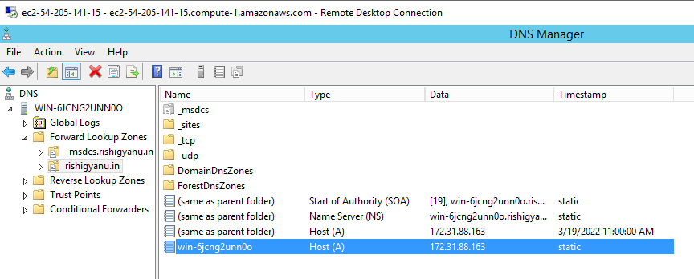

1. Click on mouse of right side and go to property

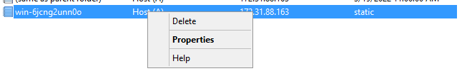

1. Put the private IP address of server > click on apply > ok .

Come back on home page of server .

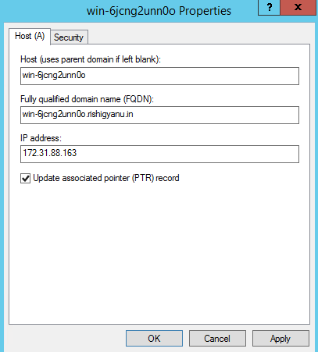

**1.4** **Now in ethernet setting > enter private IP of server in preferred DNS server.**

1. Open run > and ncpa.cpl and click on next.

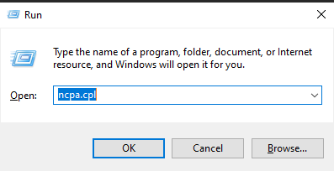

1. Ethernet > select IPv 4 deselect IPv 6 click on ok.

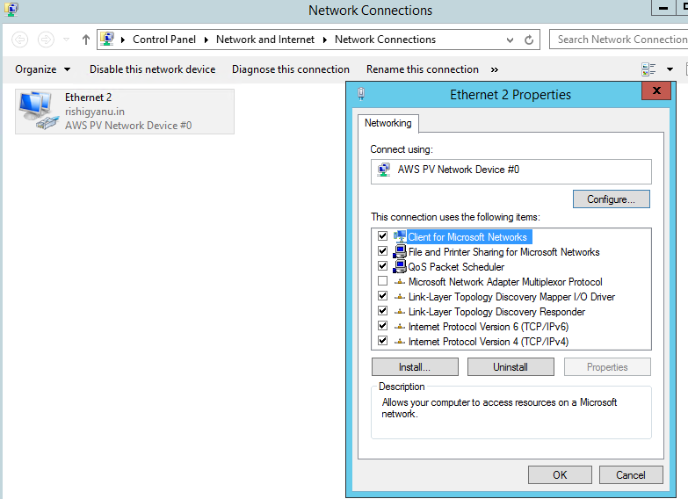

1. Put the ip address of server “172.31.88.163” and click on next.

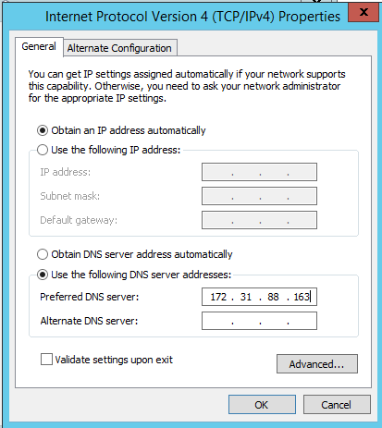

1. Come back on home page of server.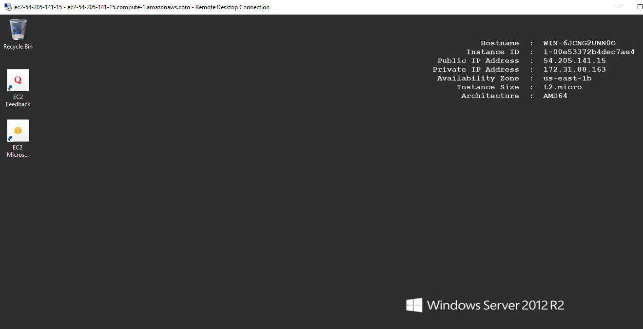

Go to run cmd and type nslookup

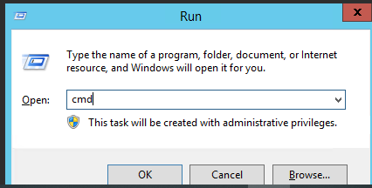

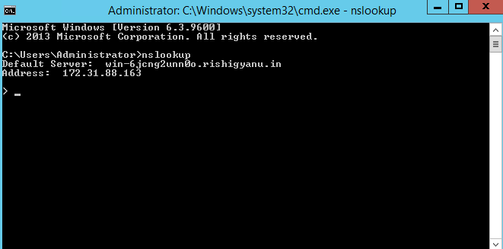

Here show my domain name rishigyau.in

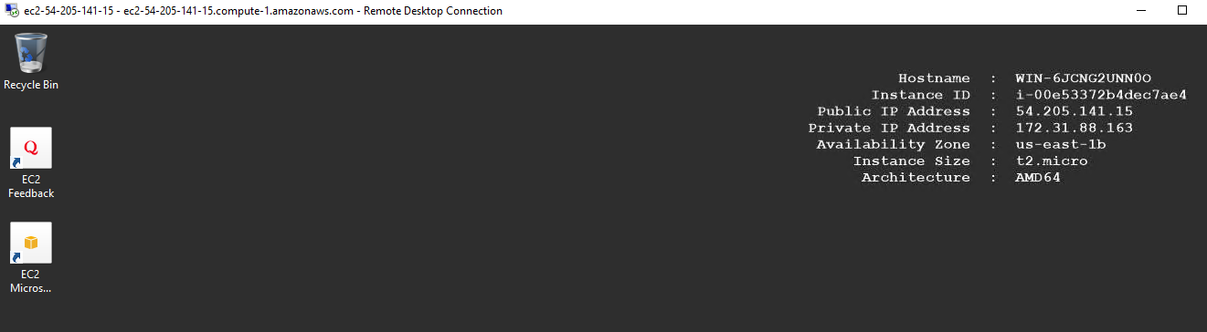

**1.5 Now click on server manager > tools > AD user & computer**

* Create two user 1rishi 2gyanu.
* Password - truth@123



Go to tools



1. Select “active directory user and computer “

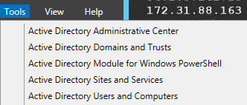

1. Rishigyanu.in **>** user click on right side of mouse **>**  new **>** user.

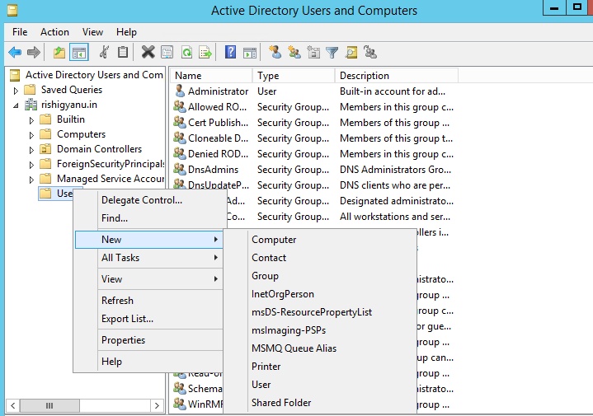

1. Create user “rishi” click on next

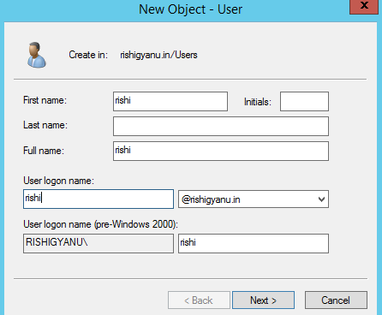

1. Password - truth@123 and confirm then click next

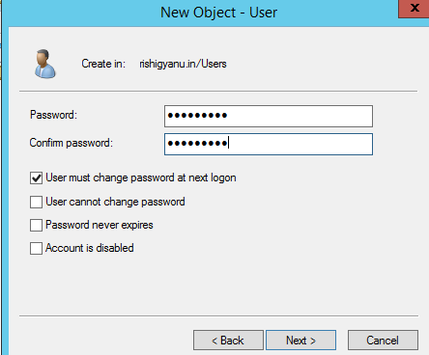

1. Create second user “gyanu” click on next.

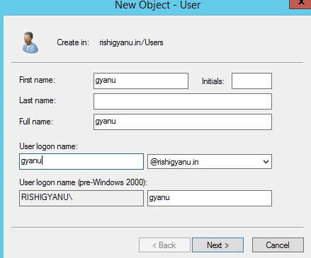

1. Password - truth@123 confirm and click on next.

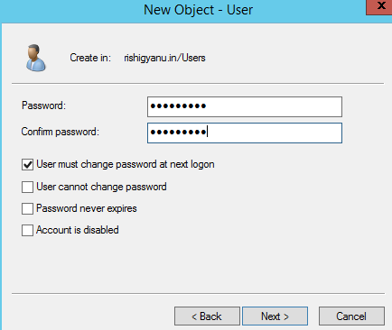

1. Come back on home page.

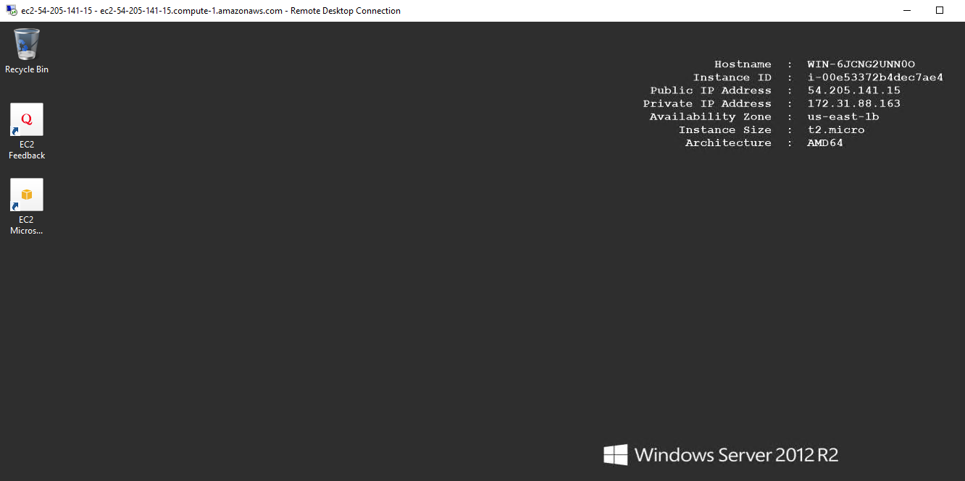

**1.6 Go to aws management console , search directory service > AD connector.**

1. Directory service click on that.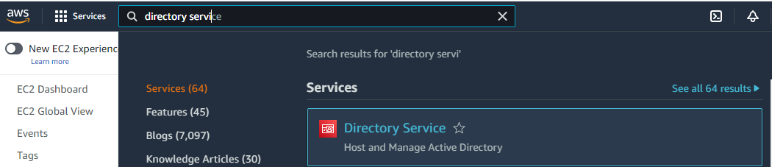

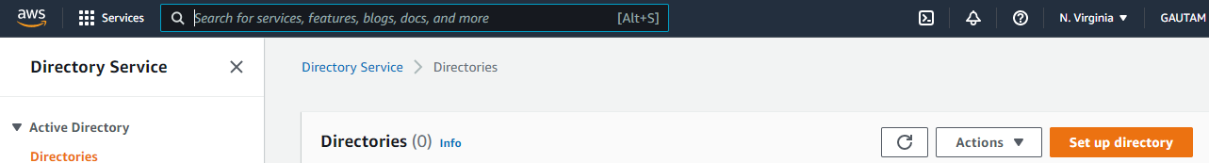

1. Select AD connector

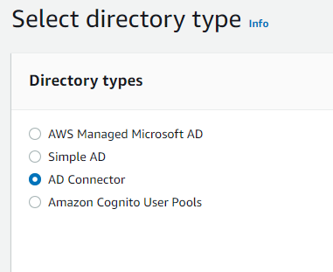

1. Select small because i am doing lab so prefer less amount of directory type small.

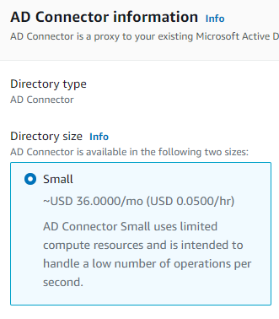



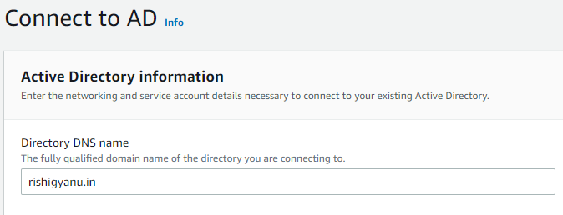

1. Put Directory DNS name rishigyanu.in



1. Dns ip address is 172.31.88.163

Service account name is administrator by default

Password - same of server “ gautam@123”

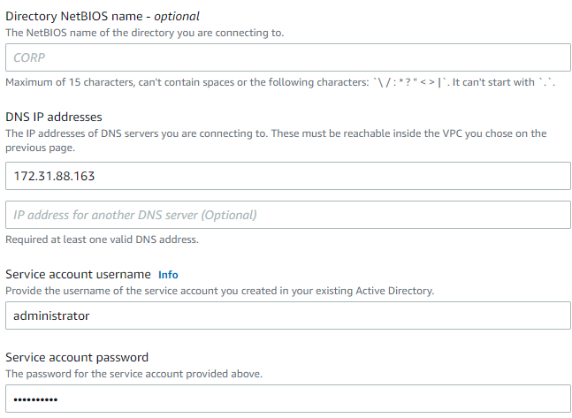

1. Password “gautam@123”

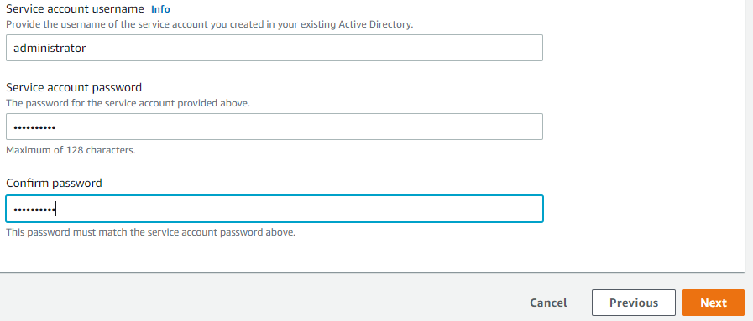

1. Located here select directory type small.

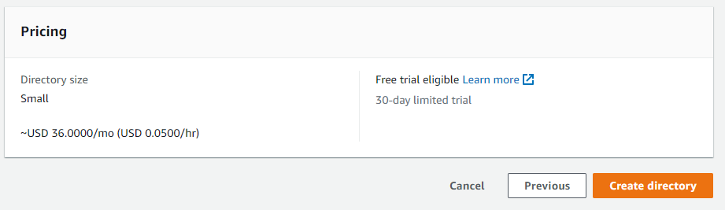

1. Successfully created of directory as can see detail of directory.

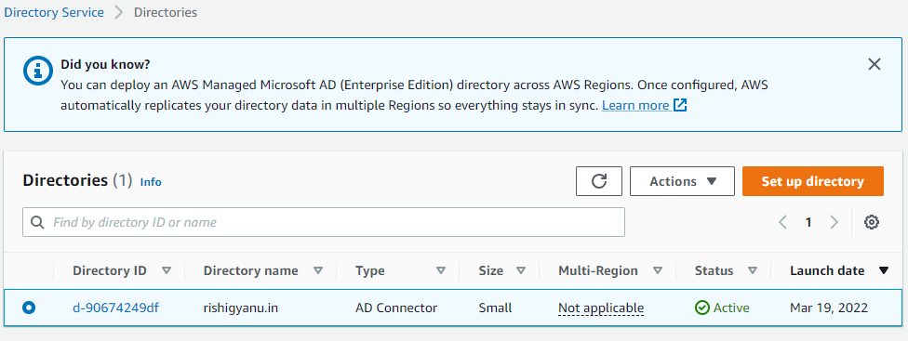

**1.7** **Go to > Role > directory > ec2 fullaccess > create Role .**

1. Service **>** security, identity & compliance **>** IAM

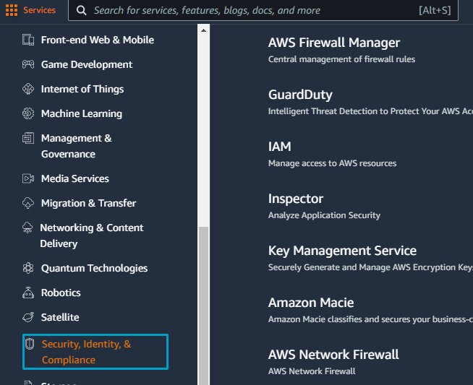



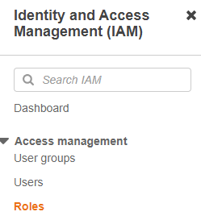

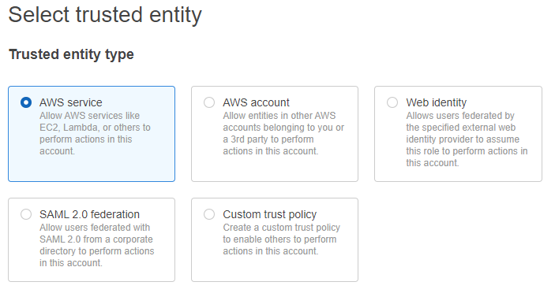

1. Select directory service click on next

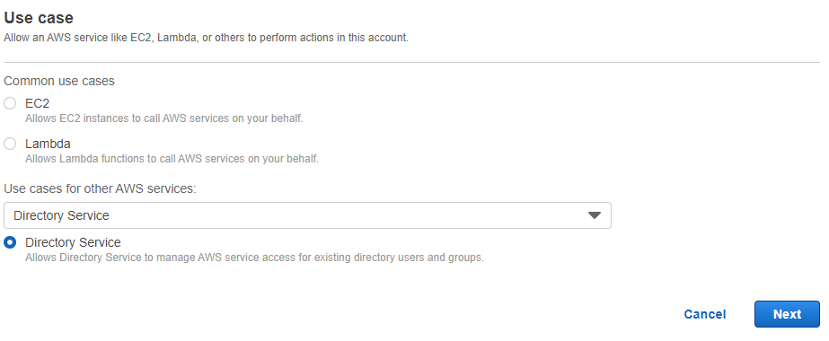

1. Role name ec2fullaccess and click on next

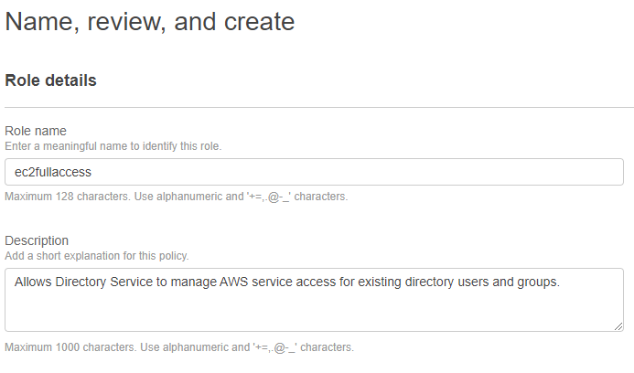



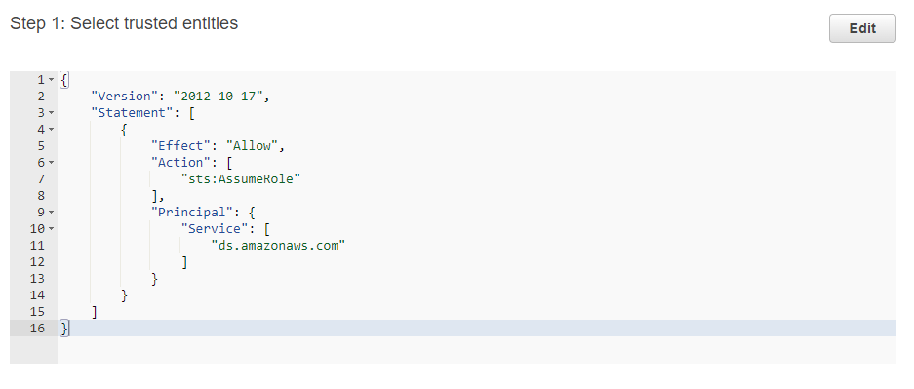



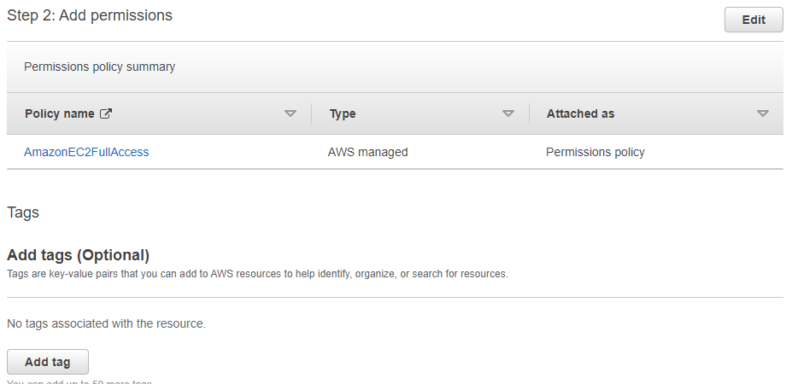

1. Show summery which i selected.

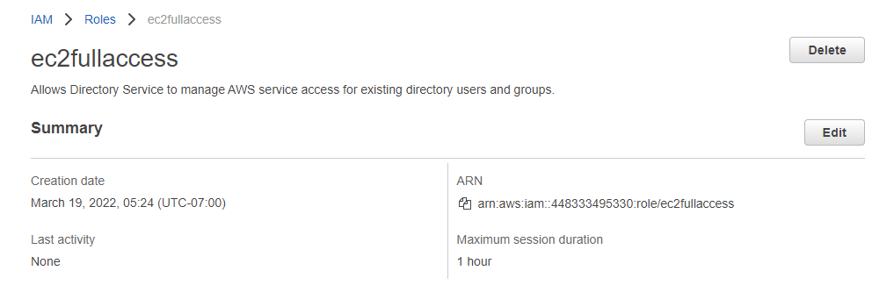

1. Select billing

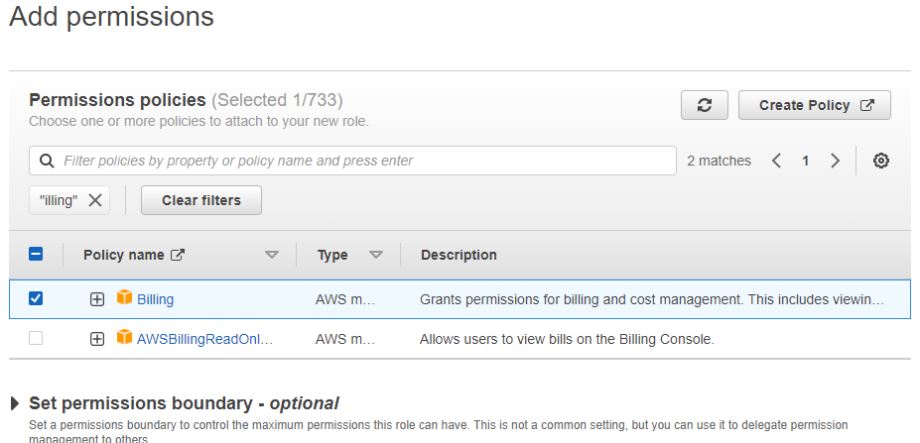

1. Role name billing1.

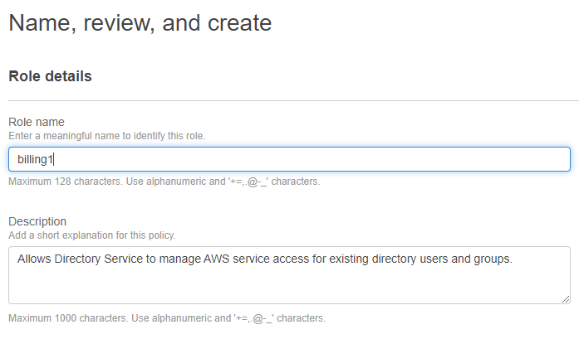



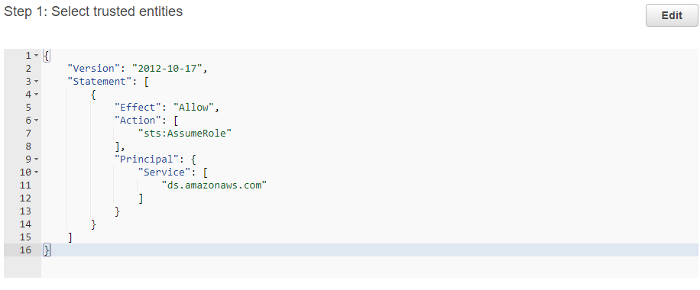



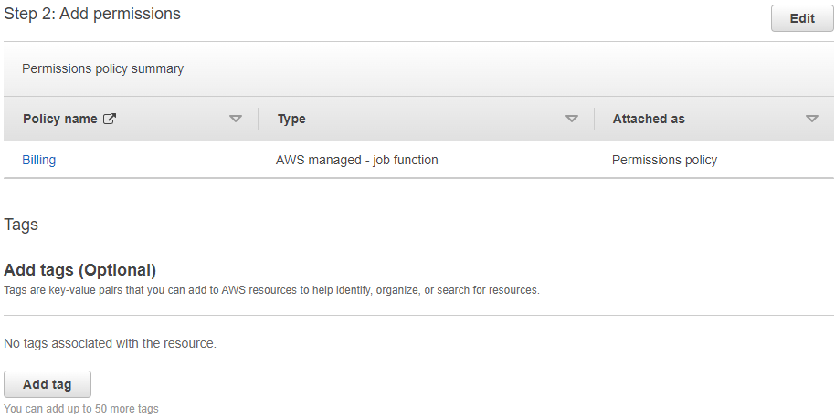

1. It successfully created.

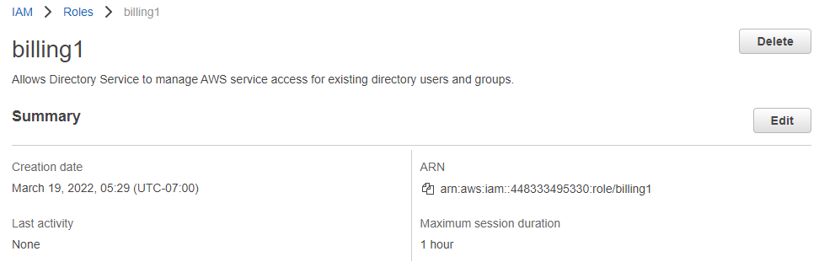

**1.8 Now add the role with user wich created rishi and gyanu**

1. Service **>** directory.

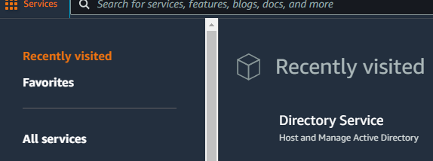



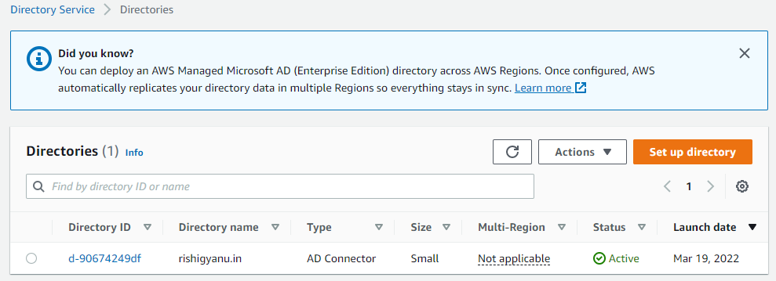



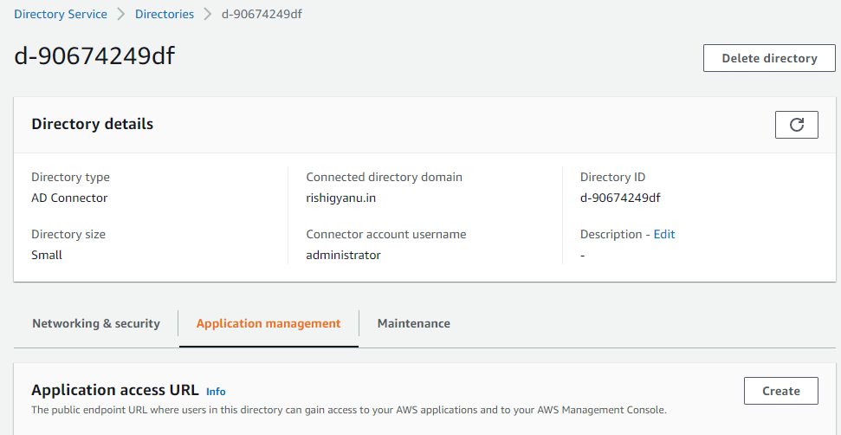

1. Create application access URL and click on create.

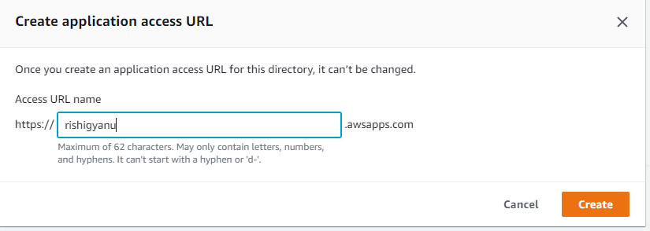







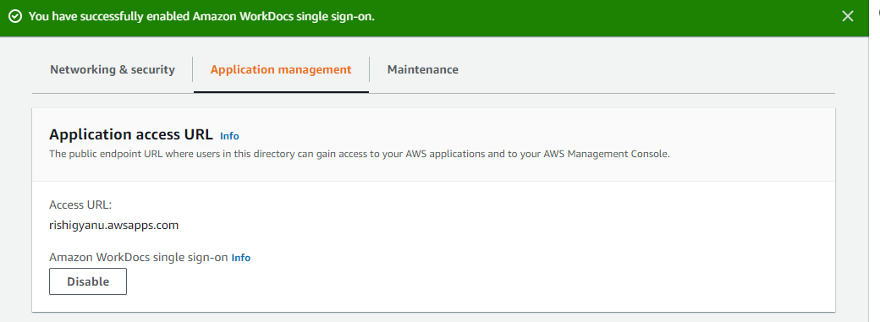

1. Go to billing1 role.

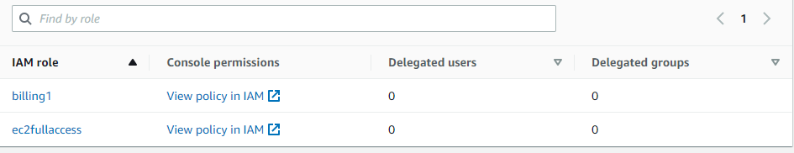

1. Now click on add

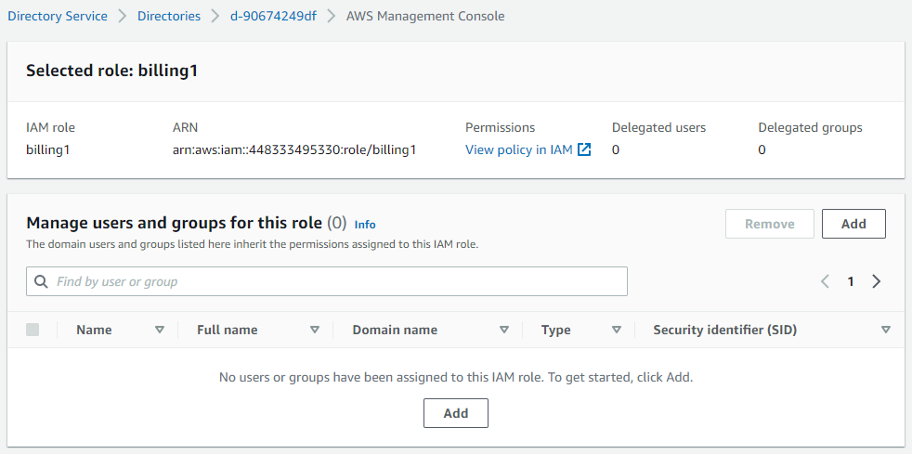

1. Search rishi and add

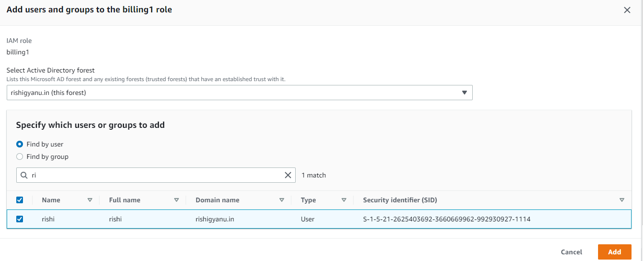

1. It added.

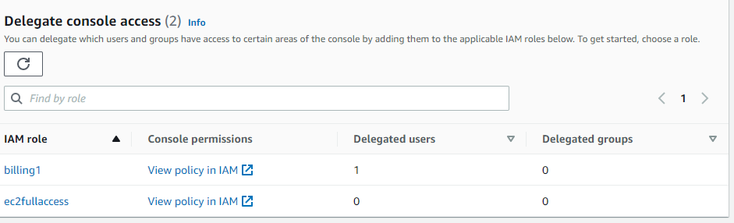

1. Go to ec2fullaccess and click on add.

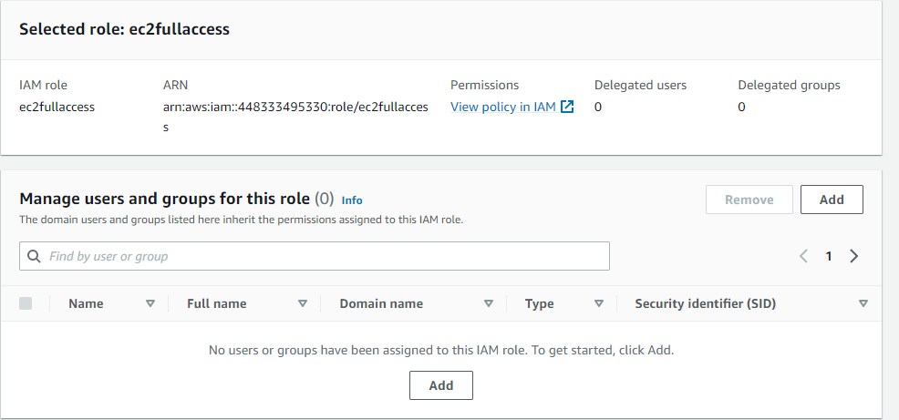

1. Search gyanu and click on add.

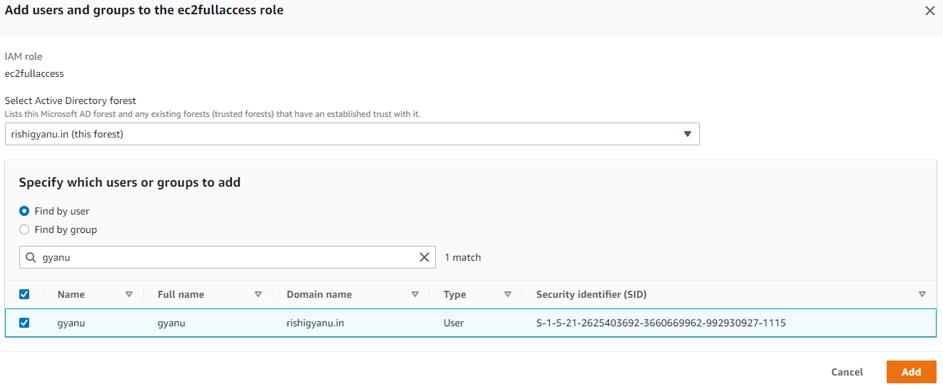

1. It successfully added .

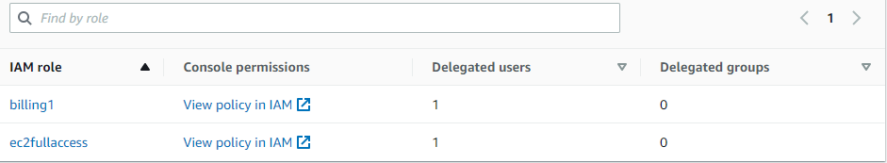

**1.9 Copy the URL/console & paste in incognito tab.**





1. It user risi and his role is access billing so it can’t access other services. As can see

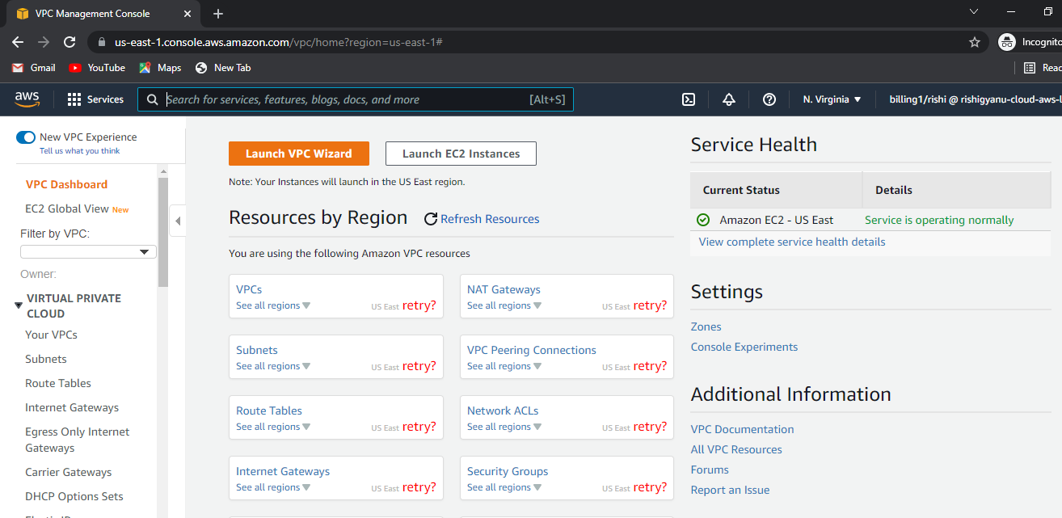

1. Perfect it access the billing information as can see.

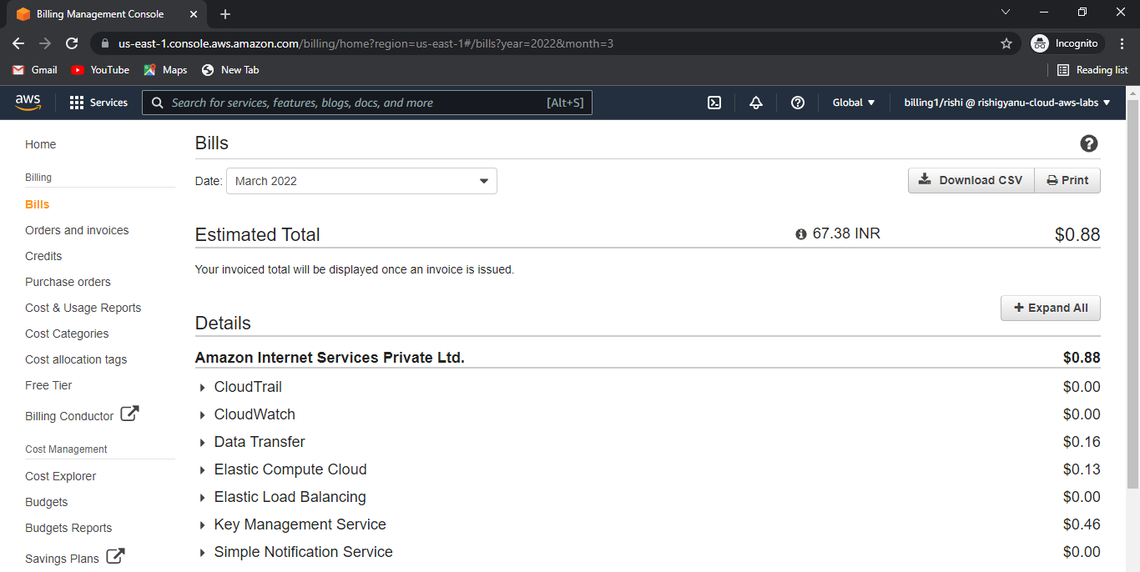

1. User gyanu and it’s role to access full ec2 service.

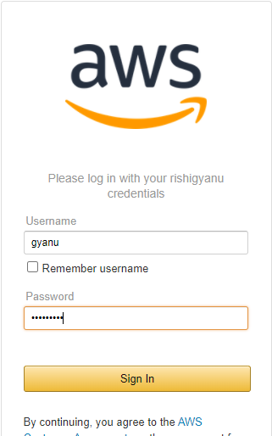

1. It acn’t access billing information s can see.

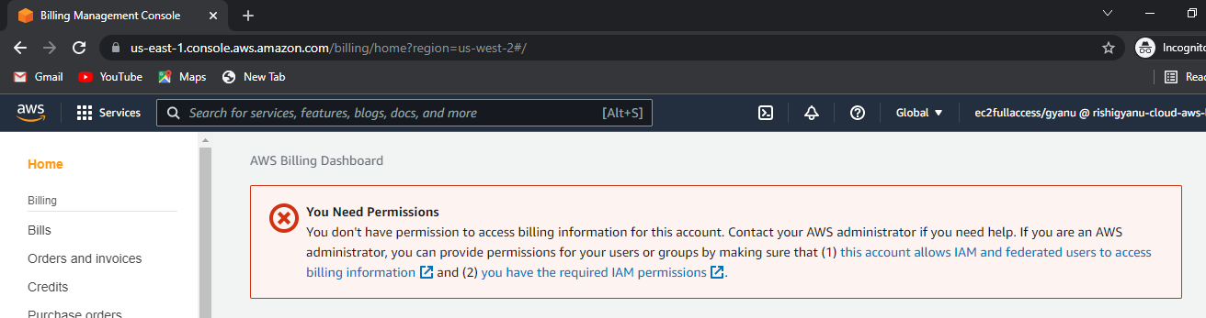

1. Go to compute > ec2

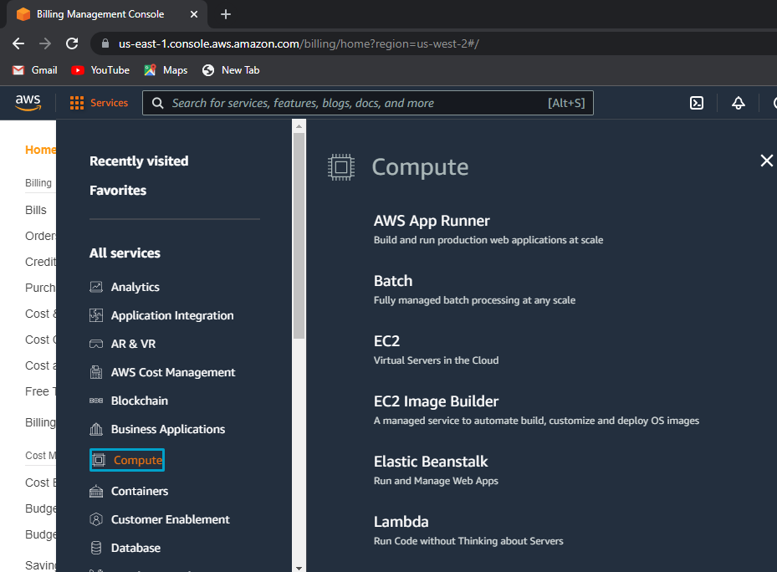

1. Perfect it can access ec2 as can see.

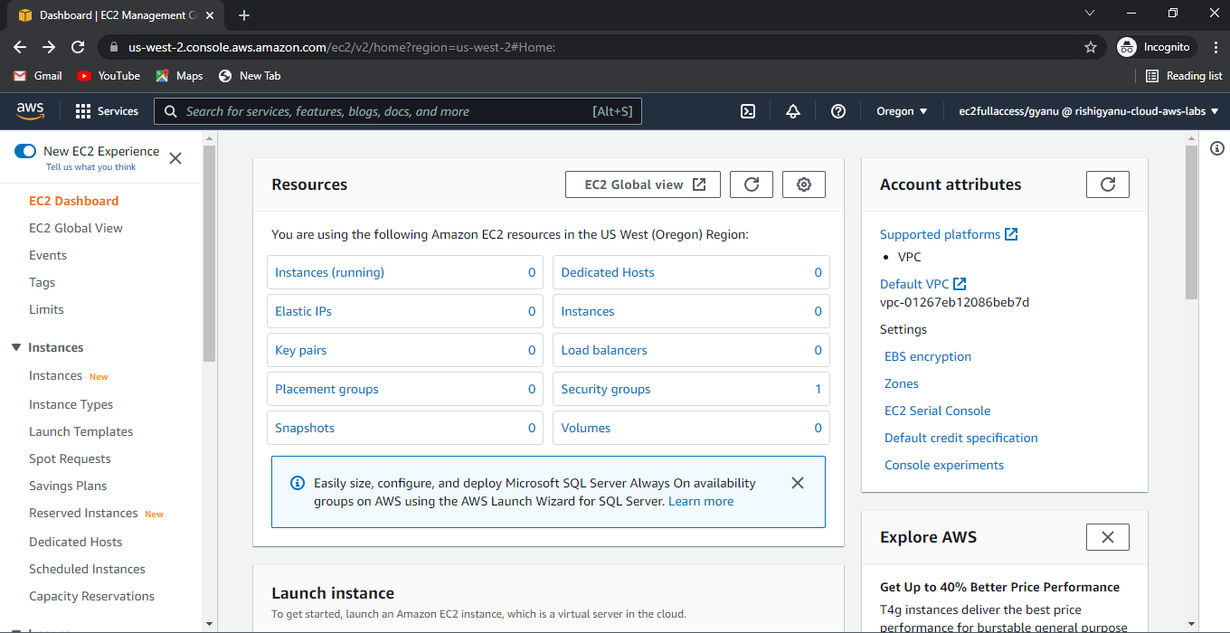

1. As can see it able to launce instance

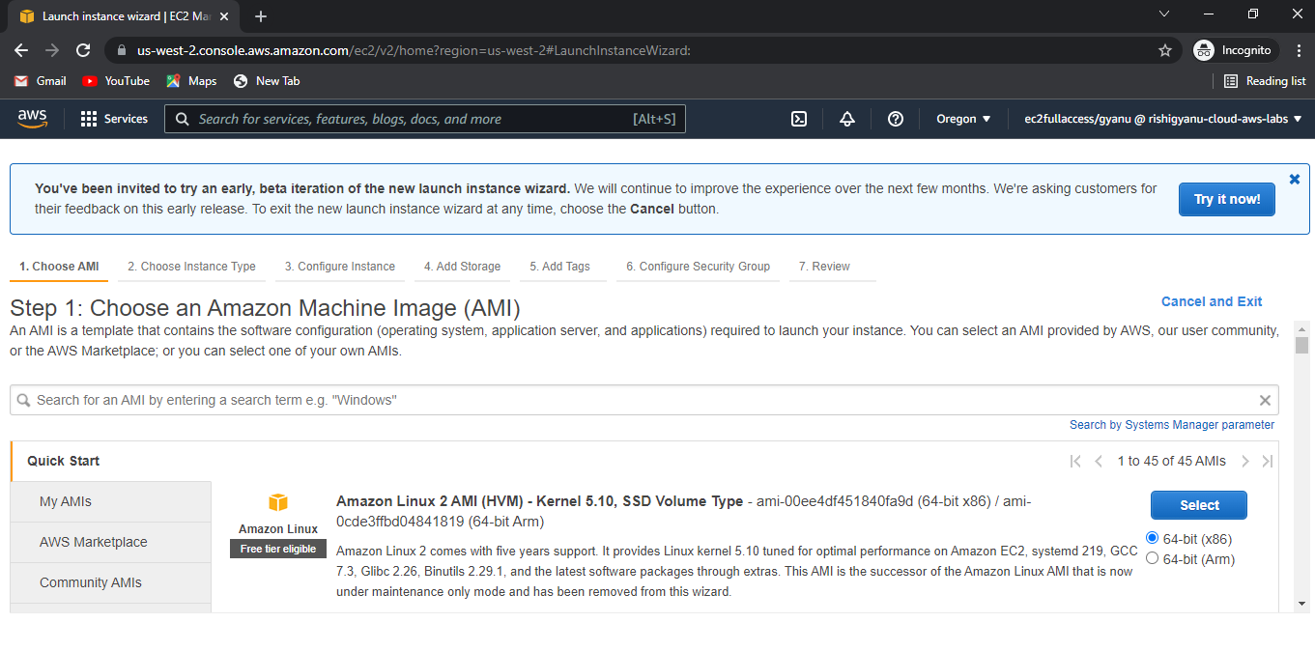

**My lab is successfully done**

**Summery**

1. create one windows server 2012 R2 base.
2. Change it’s password and then install sd server in add role and features.
3. Now create one forest i.e. “rishigyanu.in”
4. Now go to server manager > tools > DNS > reverse lookup zone and forward lookup zone > associated pointer > apply.
5. Now in ethernet setting > enter private ip of sever in preferred DNS server.
6. Now click on server manager > tools > AD user & computer create two user “rishi and gyanu” password - truth@123
7. Now go to aws management console , search ‘directory services’ > ad connector
8. Directory DNS name - rishigyanu.in

* Dns ip address - private ip and ad server
* User name - administrator
* Password - same as ad server password

1. Go to IAM > role > directory services > ec2 full access > create role
2. Create one more role for billing
3. Add user “rishi and gyanu” to above role
4. Copy the URL and paste in incognito tab.